Day 1
Review Exercise - Page 102 # 1 - 4
  - see back of book
Exercise - Page 102-103 # 1- 11 odd
1 See back of book

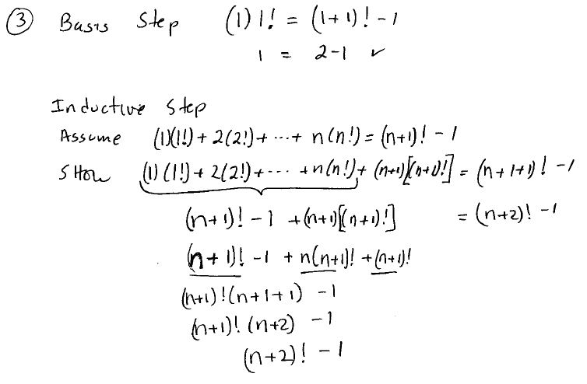

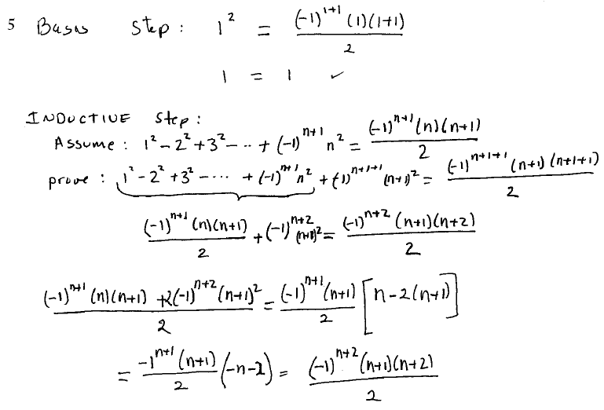

7. See back of book

